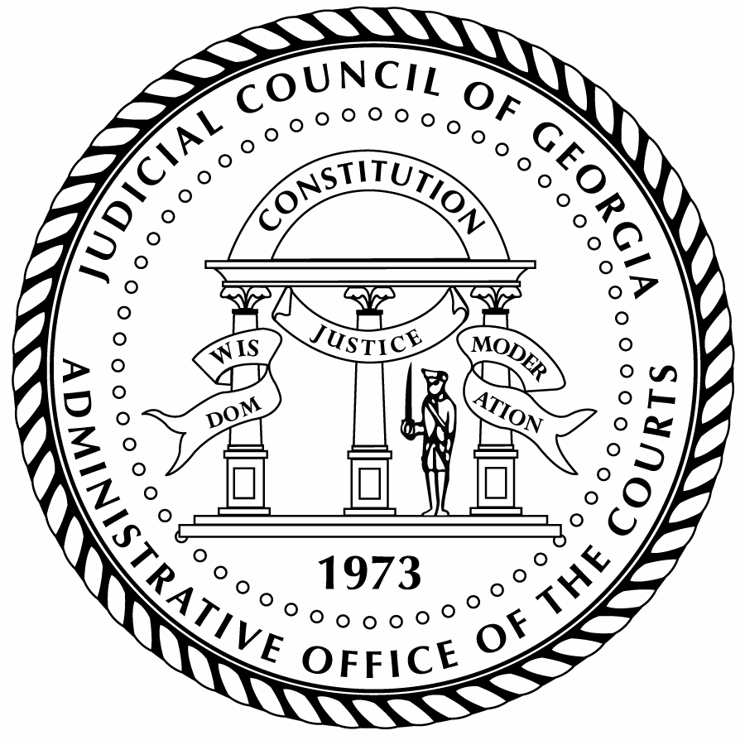
Judicial Council of Georgia

Administrative Office of the Courts

Chief Justice Nels S.D. Peterson Cynthia H. Clanton
Chair Director

PRESS RELEASE

For more information:
Bruce Shaw
bruce.shaw@georgiacourts.gov
470-585-2781
For Immediate Release

Judicial Council of Georgia to Meet on April 11, 2025
Atlanta, GA — The Judicial Council of Georgia, chaired by Chief Justice Nels S.D. Peterson, will meet for a General Session on Friday, April 11, 2025, beginning at 10:00 a.m. at the Nathan Deal Judicial Center in Atlanta. A livestream will be provided on the Judicial Council of Georgia’s YouTube channel at https://www.youtube.com/judicialcouncilofgeorgia.
The Council will consider reports from several committees, including Legislation, Budget, Artificial Intelligence and the Courts, ARPA Funding, Technology, Judicial Workload Assessment, Georgia Case Management System, Court Interpreters, Judicial Security, and Grants.
The 28-member Judicial Council of Georgia meets several times a year to act on policy and administrative matters affecting the judiciary. Judges from Georgia’s appellate and trial courts at all levels are represented on the Judicial Council, as well as a representative from the State Bar of Georgia. For more information about the Judicial Council and this meeting, including the agenda and meeting materials, visit https://jcaoc.georgiacourts.gov/judicial-council/.

