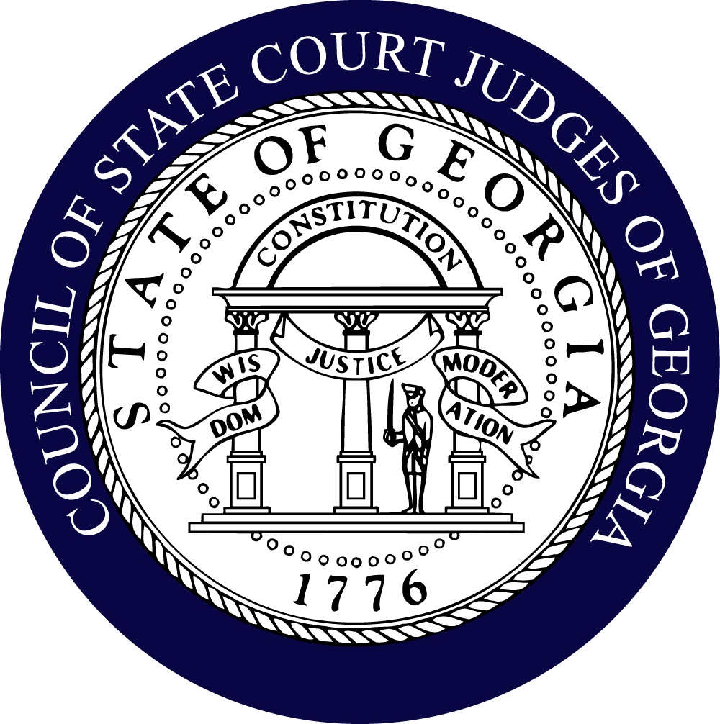

Council of State Court Judges of Georgia

“Impartial Courts – Judicial Excellence – Accessible and Efficient Justice”

244 Washington Street Telephone 404-651-6204
Suite 300 Facsimile 404-463-5173
Atlanta, GA 30334 E-Mail Bob.Bray@georgiacourts.gov

2026-2027 COMMITTEE ASSIGNMENTS
(as of July 1, 2026)

EXECUTIVE

President Susan E. Edlein (Fulton)
President Elect Eric A. Richardson (Fulton)
Secretary: Jason B. Thompson (Fayette)
Treasurer: Allison B. Salter (Cobb)
Past President: Gregory V. Sapp (Chatham)
Chair Part-Time Judges Sam Edgar (Bacon)
District 1: Billy Tomlinson (Bryan)
District 2: R. Violet Bennett (Wayne)
District 3: Ellen S. Golden (Lowndes)
District 4: Vince Lotti (Henry)
District 5: Monique Walker (Richmond)
District 6: Kelley M. Robertson (Hall)
District 7: Mike Jacobs (DeKalb)
District 8: Michelle H. Helhoski (Cherokee)

BENCH/CHARGE BOOK
Chair: Diane Bessen (Fulton)
Vice-Chair Sharell Lewis (Bibb)

- Kimberly Anderson (DeKalb)
- Jason Ashford (Houston)
- Steve Campbell (Habersham)
- Susan Edlein (Fulton)
- Maria Golick (Cobb)
- Ashanti Pounds (Richmond)
- Jay Roth (Fulton)
- Jaletta Smith (Gwinnett)
- John Stephenson (Dougherty)
- Ben Studdard (Sr. Henry)
- Wes Tailor (Fulton)
- Josh Thacker (Spalding)

BUDGET
Chair: Brian Ross (DeKalb)
Vice-Chair: Billy Mullinax (Walker)

- Vi Bennett (Wayne)
- John Edwards (Lowndes)
- Susan Edlein (Fulton)
- Greg Fowler (Sr. Chatham)
- Ellen Golden (Lowndes) – JRS Rep
- Maria Golick (Cobb) Past Chair
- Jeff Hanson (Bibb)
- Russ McClelland (Forsyth)
- Eric Richardson (Fulton)
- Allison Salter (Cobb)
- Greg Sapp (Chatham)
- Wes Tailor (Fulton)
- Jason B. Thompson (Fayette)
- Al Wong (DeKalb)

CASE COUNTING STANDARDS
Chair: Michelle Helhoski (Cherokee)
Vice-Chair: Jane Morrison (Fulton)*

- Kimberly Alexander (DeKalb)*
- Robert Alexander (Jackson)*
- Jason Ashford (Houston)*
- Larry Baldwin (Hall)
- Vi Bennett (Wayne)*
- Eric Brewton (Cobb)*
- Ronda Colvin (Gwinnett)*
- Sharell Lewis (Bibb)*
- Russ McClelland (Forsyth)
- Bill Mills (Early)
- Greg Sapp (Chatham)*
- Jason Thompson (Fayette)

*Needs Assessment members

CONFERENCE VENUE SITE COMMITTEE
Chair: Margaret Spencer (Clayton)
Vice-Chair: Kimberly Alexander (DeKalb)

- Charles Auslander (Clarke)
- Carla Brown (Gwinnett)
- Libby Coolidge (Chatham)
- Jason Fincher (Cobb)
- Janis Gordon (Sr. DeKalb)
- Michelle Helhoski (Cherokee)
- John Holland (Turner)
- Steve Jenkins (Elbert)
- Marsha Lake (Cobb)
- Hugh McCullough (Tattnall)
- Donny Peppers (Sr. Walker)
- Allison Salter (Cobb)
- Greg Sapp (Chatham)
- Lynne Moore Nelson ((ICJE)

COURT BUSINESS OPERATIONS AND ADMINISTRATION
Co-Chairs: Chief Judge Carla Brown (Gwinnett) and Chief Judge Larry Baldwin (Hall)

- Chief Judge Charles Auslander (Clarke)
- Chief Judge Eddie Barker (Douglas)
- Chief Judge Eric Brewton (Cobb)
- Chief Judge John Edwards (Lowndes)
- Chief Judge Michel Garrett (Clayton)
- Chief Judge Jeff Hanson (Bibb)
- Chief Judge Michael Hubbard (Carroll)
- Chief Judge Mike Jacobs (DeKalb)
- Chief Judge Alan Jordan (Cherokee)
- Chief Judge Vince Lotti (Henry)
- Chief Judge-to-be Angela O’Conor (Paulding)
- Chief Judge Russ McClelland (Forsyth)
- Chief Judge Kellie McIntyre (Richmond)
- Judge Jane Morrison (Fulton)
- Chief Judge Seay Poulakos (Coweta)
- Chief Judge Andy Prather (Muscogee)
- Chief Judge Richard Read (Rockdale)
- Chief Judge Greg Sapp (Chatham)
- Chief Judge Josh Thacker (Spalding)
- Chief Judge Billy Tomlinson (Bryan)
- District 1 Judge Billy Tomlinson (Bryan)
- District 2 Judge Vi Bennett (Wayne)
- District 3 Judge Ellen Golden (Lowndes)
- District 4 Judge Brian Fortner (Douglas)
- District 5 Judge Monique Walker (Richmond)
- District 6 Judge Kelley Robertson (Hall)
- District 7 Judge Mike Jacobs (DeKalb)
- District 8 Judge Michelle Helhoski (Cherokee)

DUI/DRUG COURT COMMITTEE
Co-Chairs: Eddie Barker (Douglas) and Jason Thompson (Fayette)
Recording Secretary: TBD

- Kimberly Anderson (DeKalb)
- Jason Ashford (Houston)
- Charles Auslander (Clarke)
- Larry Baldwin (Hall)
- Emily Brantley (Gwinnett)
- Shawn Bratton (Gwinnett)
- Leon Braun (Sr. Liberty)
- Eric Brewton (Cobb)
- Bridgette Campbell (Cobb)
- Melodie Clayton (Sr. Cobb)
- John Dennis (Chattooga)
- Susan Edlein (Fulton)
- Sid Esary (Sr. Spalding)
- Brian Fortner (Douglas)
- Greg Fowler (Sr. Chatham)
- Ellen Golden (Lowndes)
- Michelle Helhoski (Cherokee)
- Ryan Hope (Clarke)
- Steve Jenkins (Elbert)
- Alan Jordan (Cherokee)
- Wesley Leonard (Troup)
- Sharell Lewis (Bibb)
- Vincent Lotti (Henry)
- Russ McClelland (Forsyth)
- Kellie McIntyre (Richmond)
- Ana Maria Martinez (DeKalb)
- Dee Morris (Cherokee)
- Angela O’Conor (Paulding)
- Jeffery Osteen (Liberty)
- Seay VanPatten Poulakos (Coweta)
- Ashanti Pounds (Richmond)
- Ralph Powell (Worth)
- Kelley Robertston (Hall)
- Greg Sapp (Chatham)
- Margaret Spencer (Clayton)
- Kiesha Storey (DeKalb)
- Wes Tailor (Fulton)
- Josh Thacker (Spalding)
- Michael Hubbard (Carroll)
- Derek White (Chatham)
- Al Wong (DeKalb)

EDUCATIONAL PROGRAMS
*Co-Chairs: Eric A. Richardson (Fulton) and
Sherell Lewis (Bibb)

- Kimberly Alexander (DeKalb)
- Kimberly Anderson (DeKalb)
- Jason Ashford (Houston)
- Diane Bessen (Fulton)
- Eric Brewton (Cobb)
- Bridgette Campbell (Cobb)
- Ronda Colvin (Gwinnett)
- John Edwards (Lowndes)
- Ellen Golden (Lowndes)
- Janis Gordon (Sr. DeKalb)
- Jeff Hanson (Bibb)
- Michelle Helhoski (Cherokee)
- Alan Jordan (Cherokee)
- Marsha Lake (Cobb)
- Sharell Lewis (Bibb)
- Yolanda Mack (DeKalb)
- Shalonda Jones-Parker (Clayton)
- Ashley Palmer (Cobb)
- Wayne Purdom (DeKalb)
- Kelly Robertson (Hall)
- Margaret Spencer (Clayton)
- Kiesha Storey (DeKalb)
- Ben Studdard (Sr. Henry)
- Monique Walker (Richmond)
- Lynne Moore Nelson (ICJE)

LEGISLATIVE
Co-Chairs: Maria Golick (Cobb) and Greg Sapp (Chatham)

- Jason Ashford (Houston)
- Larry Baldwin (Hall)
- Vi Bennett (Wayne)
- Diane Bessen (Fulton)
- Carla Brown (Gwinnett)
- Steve Campbell (Habersham)
- Ronda Colvin (Gwinnett)
- Libby Coolidge (Chatham)
- David Darden (Sr. Cobb)
- Susan Edlein (Fulton)
- John Edwards (Lowndes)
- Brian Fortner (Douglas)
- Robert Gardner (Barrow)
- Sonyja George (Clayton)
- Ellen Golden (Lowndes)
- Jeff Hanson (Bibb)
- John Holland (Turner)
- Mike Jacobs (DeKalb)
- Alan Jordan (Cherokee)
- Stephen Knights (Henry)
- Russ McClelland (Forsyth)
- Jane Manning (Cobb)
- Jeffery Osteen (Liberty)
- Shalonda Jones Parker (Clayton)
- Eric Richardson (Fulton)
- Jay Roth (Fulton)
- Donald Sheppard (Screven)
- Margaret Spencer (Clayton)
- Ben Studdard (Sr. Henry)
- Wes Tailor (Fulton)
- Jason Thompson (Fayette)
- Billy Tomlinson (Bryan)
- Bobby Wolf (Fulton)
- Al Wong (DeKalb)

MANDATORY CJE
Chair: Eric Brewton (Cobb)
Vice-Chair: Billy Mullinax (Walker)

- Kimberly Anderson (DeKalb)
- Jason Ashford (Houston)
- Erica Dove (Gwinnett)
- John Edwards (Lowndes)
- Stephen Knight (Henry)
- Monique Walker (Richmond)
- Rick Waters (Mitchell)
- Lynne Moore Nelson (ICJE)

MENTORING
Chair: Tammi Hayward (Clayton)
Vice-Chair: Ana Maria Martinez (DeKalb)

- R. Violet Bennett (Wayne)
- Ellen Golden (Lowndes)
- Michelle Helhoski (Cherokee)
- Mike Jacobs (DeKalb)
- Eric Richarson (Fulton)
- Kelley Robertson (Hall)
- Jason Thompson (Fayette)
- Billy Tomlinson (Bryan)

MISDEMEANOR MENTAL HEALTH
Chair: Patsy Porter (Fulton)

- Eric Brewton (Cobb)
- Veronica Cope (Gwinnett)
- Maria Golick (Cobb)
- Ellen Golden (Lowndes)
- Michelle Helhoski (Cherokee)
- Sharell Lewis (Bibb)
- Pam South (Gwinnett)
- John Stephenson (Dougherty)
- Monique Walker (Richmond)

NEW JUDGE EDUCATION
Chair: Ronda Colvin (Gwinnett)
Vice-Chair: TBD
Recording Secretary: Jason Thompson (Fayette)

- Charles Auslander (Clarke)
- Eddie Barker (Douglas)
- Eric Brewton (Cobb)
- Carla Brown (Gwinnett)
- Melodie Clayton (Sr. Cobb)
- Ronda Colvin (Gwinnett)
- John Edwards (Lowndes)
- Susan Edlein (Fulton)
- Ellen Golden (Lowndes)
- Janis Gordon (Sr. DeKalb)
- Jeff Hanson (Bibb)
- Tammi Hayward (Clayton)
- Steve Jenkins (Elbert)
- Sharell Lewis (Bibb)
- Kellie McIntyre (Richmond)
- Seay Poulakos (Coweta)
- Josh Thacker (Spalding)
- Billy Tomlinson (Bryan)
- Al Wong (DeKalb)
- Lynne Moore Nelson (ICJE)

NOMINATING
Chair: Vi Bennett (Wayne)

- Steve Campbell (Habersham)
- John Edwards (Lowndes)
- Jeff Hanson (Bibb)
- Ashley Palmer (Cobb)
- Greg Sapp (Chatham)
- Ben Studdard (Sr. Henry)

PART-TIME JUDGES
Chair: Sam Edgar (Bacon)
Vice-Chair: TBD

- Vi Bennett (Wayne)
- Robert Gardner (Barrow)
- James Garner (Treutlen)
- Ron Hallman (Evans)
- Hugh McCullough (Tattnall)
- Hubert Reeves (Sr. Jenkins)

PERSONNEL COMMITTEE

Chair: Al Wong (DeKalb)

- David Darden (Sr. Cobb)
- Greg Fowler (Sr. Chatham)
- Jeff Hanson (Bibb)
- Russ McClelland (Forsyth)
- Wes Tailor (Fulton)
- Al Wong (DeKalb)

RESOLUTIONS AND AWARDS
*Chair: Jean Bolin (McIntosh)
Vice Chair: Josh Thacker (Spalding)

- Ralph Bailey (Henry)
- Greg Fowler (Sr. Chatham)
- Janis Gordon (Sr. DeKalb)
- Alan Jordan (Cherokee)
- Jeannette Little (Sr. Troup)
- Russ McClelland (Forsyth)
- Margaret Spencer (Clayton)

RETIREMENT
Chair: Alan Jordan (Cherokee)
Vice-Chair: Ellen Golden (Lowndes)

- Vi Bennett (Wayne)
- Pattie Booker (Sr. Richmond)
- Sam Edgar (Bacon)
- John Edwards (Lowndes)
- James Irvin (Stephens)
- Marsha Lake (Cobb)
- Eric Richardson (Fulton)
- John Stephenson (Dougherty)

SENIOR JUDGE/JUDGE EMERITUS COMMITTEE
Co-Chairs: David Darden (Sr. Cobb) and TBD

- Greg Fowler (Sr. Chatham)
- Jeannette Little (Sr. Troup)
- Bob Mock (Sr. Gwinnett)
- Ben Studdard (Sr. Henry)

STRATEGIC PLANNING
Co-Chairs: Jason Thompson (Fayette) and Allison Salter (Cobb)

- Kimberly Anderson (DeKalb)
- Jason Ashford (Houston)
- Eddie Barker (Douglas)
- Vi Bennett (Wayne)
- Diane Bessen (Fulton)
- John Breakfield (Hall)
- Eric Brewton (Cobb)
- Melodie Clayton (Sr. Cobb)
- Ronda Colvin (Gwinnett)
- David Darden (Sr. Cobb)
- Sam Edgar (Bacon)
- Susan Edlein (Fulton)
- John Edwards (Lowndes)
- Greg Fowler (Sr. Chatham)
- Michael Gailey (Putnam)
- Ellen Golden (Lowndes)
- Maria Golick (Cobb)
- Jeff Hanson (Bibb)
- Tammi Hayward (Clayton)
- Michelle Helhoski (Cherokee)
- James Irvin (Stephens)
- Jeannette Little (Sr. Troup)
- Russ McClelland (Forsyth)
- John Murphy III (Jefferson)
- Wayne Purdom (DeKalb)
- Eric Richardson (Fulton)
- Shawn Rowland (Jeff Davis)
- Allison Salter (Cobb)
- Greg Sapp (Chatham)
- Danny Shepard (Miller)
- Margaret Spencer (Clayton)
- Ben Studdard (Sr. Henry)
- Wes Tailor (Fulton)
- Josh Thacker (Spalding)
- Erica Tisinger (Carroll)
- Billy Tomlinson (Bryan)
- Monique Walker (Richmond)
- Al Wong (DeKalb)

TECHNOLOGY
Co-Chairs: Jason Ashford (Houston) and Jaret Usher (Cobb)

- Harold Benefield Sr. Clayton)
- Diane Bessen (Fulton)
- Pattie Booker (Richmond)
- John Dennis (Chattooga)
- Neal Dettmering (Sr. Douglas)
- John Edwards (Lowndes)
- Jason Fincher (Cobb)
- Joe Iannazzone (Sr. Gwinnett)
- Marsha Lake (Cobb)
- Sharell Lewis (Bibb)
- Russ McClelland (Forsyth)
- Jaletta Smith (Gwinnett)
- Ben Studdard (Sr. Henry)
- Wes Tailor (Fulton)
- Monique Walker (Richmond)

UNIFORM COURT RULES
Chair, Larry Baldwin (Hall)
Vice Chair: Russ McClelland (Forsyth)

- Larry Baldwin (Hall)
- Melodie Clayton (Sr. Cobb)
- Greg Fowler (Sr. Chatham)
- Joe Iannazzone (Sr. Gwinnett)
- James Irvin (Stephens)
- Kelley Robertson (Hall)
- Greg Sapp (Chatham)
- John Stephenson (Dougherty)
- Wes Tailor (Fulton)
- John “Tripp” Wingate (Hall)

Special Appointments to Other Committees:

Institute of Continuing Judicial Education Board (ICJE)
Allison Salter (Cobb) 2 year 6/30/23

Judicial Council Records Retention Committee
Kiesha Storey (DeKalb)

Judicial Council Committee on Victims of Domestic Violence
Maria Golick (Cobb)

Judicial Council Committee
On Artificial Intelligence
Jaletta Smith (Gwinnett) President Appointment March 2026
Brian Fortner (Douglas) President Appointment on March 2026

State Bar Committee on Artificial Intelligence
Jane Manning (Cobb)

Judicial Council Technology Committee
Jason Ashford (Houston) June 30, 2026
Jaret Usher (Cobb) June 30, 2026

Judicial Council Committee on Grants
Eric Richardson (Fulton) June 30, 2026

Judicial Council Committee on Interpreters
Elizabeth E. Coolidge (Chatham) June 30, 2028

Supreme Court – Board to Determine Fitness of Bar Applicants
Janis Gordon (Sr. DeKalb)

Judicial Council Committee on Emergency Preparedness and Continuity of Court Operations
Eric Richardson (Fulton)
Bob Bray – Advisory Member

Pre-Trial Justice in Georgia
Wes Tailor (Fulton)

Judicial Council Legislative Committee
Susan Edlein (Fulton)
Maria Golick (Cobb)
Greg Sapp (Chatham)
Bob Bray (Advisory)
Council of Accountability Courts
Charles E. Auslander, III (Clarke) –Chair
Jason Thompson (Fayette) – Exec. Committee
Margaret Spencer (Clayton) – Advisory Member

Georgia Commission on Dispute Resolution
Charles E. Auslander, III (Clarke)

Judicial Council Committee on Access to Justice
Jason Thompson (Fayette)
Linda Cowen (Clayton)
Jane Morrison (Fulton)

Chief Justice’s Commission on Professionalism
Russ McClelland - 6/30/2025

Judicial Council Committee on Judicial Security
Vi Bennett (Wayne)

Georgia Board of Court Reporting
Vi Bennett (Wayne) (Chair)

Digital Court Reporting Rules Subcommittee
Jane Morrison – Chair (Fulton)

Georgia Judicial Retirement System – Board of Trustees (Governor Appointment – 4 Year Term)
Ellen Golden (Lowndes) – 7/1/2027
Judicial Council Workload Assessment
Committee (JWAC)
Michelle Helhoski (Cherokee) Term 6/30/2024
Judicial Council Budget Committee
Eric Richardson (Fulton)
Brian Ross (DeKalb)

Governor’s Criminal Data Exchange Advisory Board:
Joseph Cushner (Bulloch)
Bob Bray (Executive Director)

Judicial Council Automated Data Collection Subcommittee
Jeff Hanson (Bibb)

Bench & Bar Committee of State Bar
Jane Manning (Cobb)
Judicial Council ARPA Committee
Vi Bennett (Wayne)

Region 4 Judicial Outreach Liaison for ABA and NHTSA
Leslie Maddox (Em. Forsyth)

Judge Edlein and Bob Bray have worked very hard on this listing and tried to put everyone who indicated an interest in being on the committee that he or she requested. If we have left someone off, it was not intentional, and he or she will be added to a committee upon request

