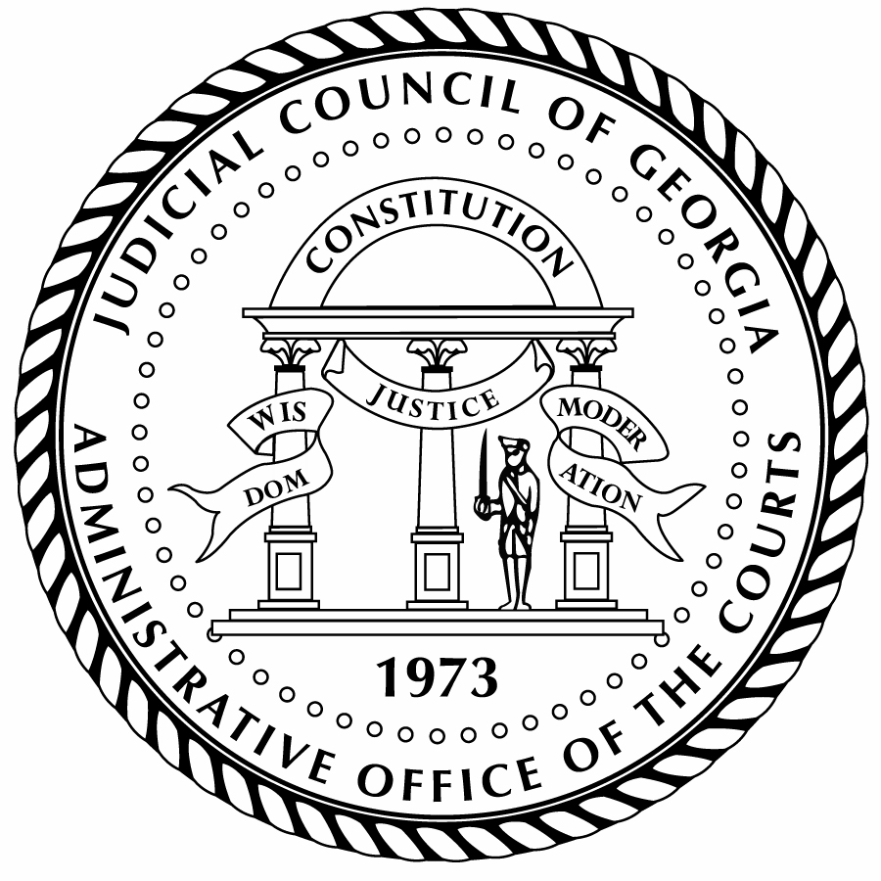
Judicial Council of Georgia

Administrative Office of the Courts

Chief Justice Nels S.D. Peterson Tracy Mason
Chair Interim Director

PRESS RELEASE

For more information:
Bruce Shaw
bruce.shaw@georgiacourts.gov
470-585-2781
For Immediate Release

Judicial Council of Georgia to Meet on October 23, 2026
Atlanta, GA — The Judicial Council of Georgia, chaired by Chief Justice Nels S.D. Peterson, will meet via teleconference for a Special Session on Friday, October 23, 2026, beginning at 2:00 p.m. The Council will consider the report and recommendation of the Ad Hoc Director Search Committee.
A livestream of the meeting will be available on the Judicial Council of Georgia’s YouTube channel at https://www.youtube.com/judicialcouncilofgeorgia.
The 29-member Judicial Council of Georgia meets several times a year to act on policy and administrative matters affecting the judiciary. Judges from Georgia’s appellate and trial courts at all levels are represented on the Judicial Council, as well as a representative from the State Bar of Georgia. For more information about the Judicial Council and this meeting, including the agenda and meeting materials, visit https://jcaoc.georgiacourts.gov/judicial-council/.

